%% Prelab6 part b

clc

clear

close all

K = 18;

Kc = 1;

Kpot = 5/(pi);

Kamp = 2.4;

tm = 0.2;

KT = K*Kc*Kpot*Kamp;

Den = conv([1,0],[tm,1]);

H1 = tf([0,0,KT],Den);

Kc = 8.9;

KT = K*Kc*Kpot*Kamp;

Den = conv([1,0],[tm,1]);

H2 = tf([0,0,KT],Den);

Kc = 2;

KT = K*Kc*Kpot*Kamp;

Den = conv([1,0],[tm,1]);

H3 = tf([0,0,KT],Den);

subplot(131)

margin(H1)

legend('K = 1',...

       'Location','Best')

subplot(132)

margin(H2)

legend('K = 8.9',...

       'Location','Best')

subplot(133)

margin(H3)

legend('K = 2',...

       'Location','Best')

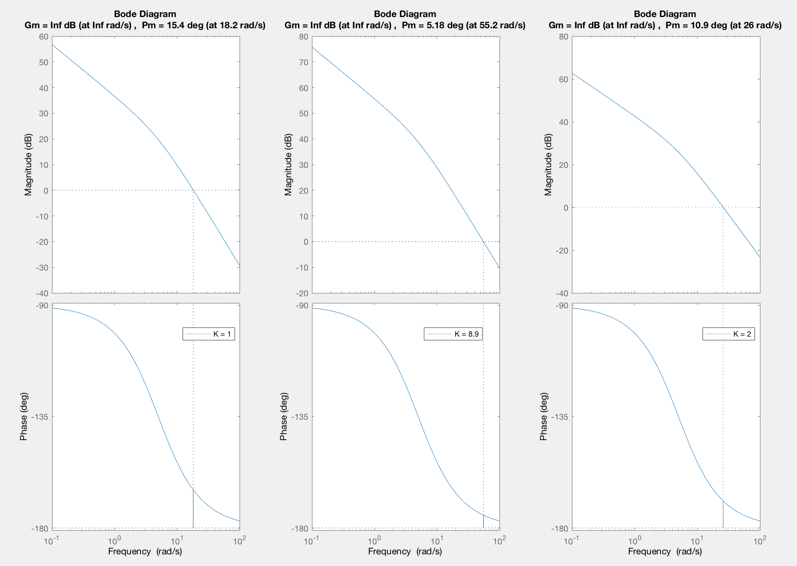

%% Prelab6 part c

clc

clear

close all

K = 10;

NUM = conv(10,[1,10]);

H = tf(NUM,[1,100]);

margin(H)

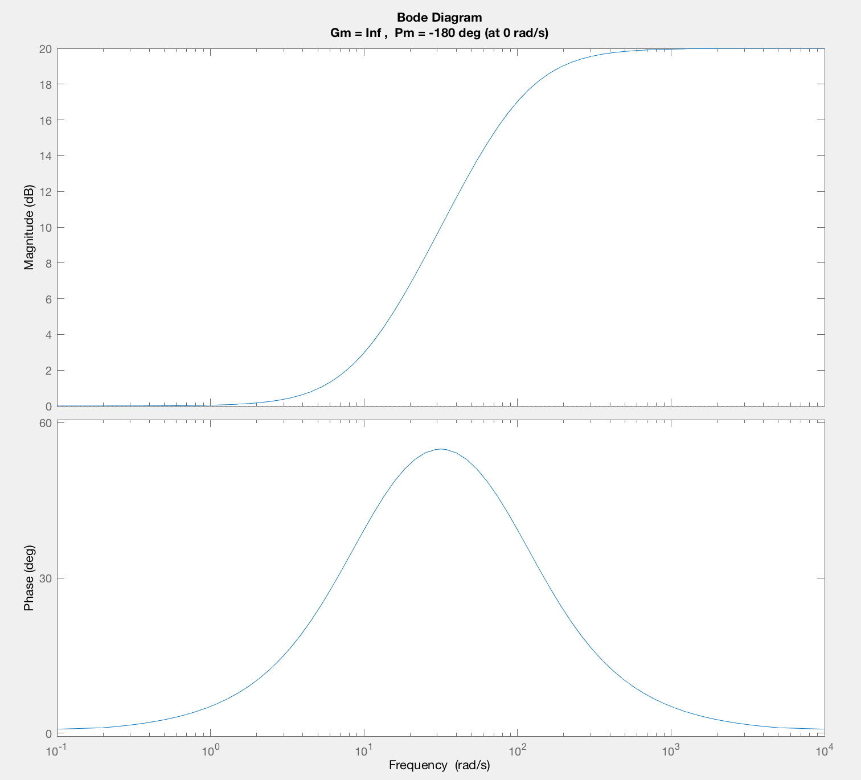

%% Prelab6 part d

clc

clear

close all

% Given

K = 18;

Kpot = 5/(pi);

Kamp = 2.4;

tm = 0.2;

%Gc Design

Wn = 55.4;

Wn2 = Wn*Wn;

Zeta = 0.5169;

H = tf(Wn2,[1,2*Zeta*Wn,0]);

[GM,PM,Wgm,Wpm] = margin(H);

PM = deg2rad(PM);

safety = deg2rad(10);

PMmotor = deg2rad(10.9);

alpha = (1-sin(PM+safety-PMmotor))/(1+sin(PM+safety-PMmotor)); % add 10 for safety

T = 1/(Wpm*sqrt(alpha));

% Realization of G

Kc = 2;

KT = Kc*K*Kpot*Kamp;

Den = conv([1,0],[tm,1]);

G = tf(KT,Den);

% Realization of Gc

Gc = tf([T,1],[T*alpha,1]);

% Realization of Close Loop System

HCL = tf(Gc*G/(1+Gc*G));

[y,t] = step(HCL);

% Mp

[M,MpIndex] = max(y);

yss = y(end);

Mp = M-yss;

if Mp<0

    Mp = 0;

else

    Mp =Mp/yss;

end

% tr

t_10index = find(  y > .1*yss, 1, 'first');

t_90index  = find(  y > .9*yss, 1, 'first');

tr = t(t_90index)-t(t_10index);

% Plots

subplot(121)

plot(t,y)

title('Step Response for KcG(s)Gc(s) for ','FontSize',14,'FontWeight','bold')

%plot the response and the bounds for 10%, 90%, 95% and 105%

ss = 1:1:size(t); % the final value

ss(:) = yss;

per105=1.05*ss;

per95=.95*ss;

per10=.10*ss;

per90=.90*ss;

plot(t,y,'-',t,per10,':r',t,per90,':r',t,per105,'-g',t,per95,'-g',t,ss,'--')

% document Mp

if(Mp > 0)

    text(t(MpIndex),y(MpIndex),'\leftarrow M_p',...

        'HorizontalAlignment','left')

    line([t(MpIndex);t(MpIndex)],[0,y(MpIndex)],...

        'Color','k','LineWidth',0.5,'LineStyle',':')

end

%document tr

text(t(t_10index),y(t_10index),'\leftarrow 10%',...

    'HorizontalAlignment','left')

line([t(t_10index);t(t_10index)],[0,y(t_10index)],...

    'Color','k','LineWidth',0.5,'LineStyle',':')

text(t(t_90index),y(t_90index),'\leftarrow 90%',...

    'HorizontalAlignment','left')

line([t(t_90index);t(t_90index)],[0,y(t_90index)],...

    'Color','k','LineWidth',0.5,'LineStyle',':')

%legend

legend(['Mp = ',num2str(Mp), '%'],...

       '10% (rise time)',...

       ['90% (rise time) = ',num2str(tr), 's'],...

       '105% ',...

       '95%',...

       '100% (Value_{steady-state})','Location','Best')

% Label the axes:

title('step response')

xlabel('t, time (sec)')

ylabel('response to step in reference')

% Root Locus

% Realization of G

Kc = 1; % Kc = 1 so we plot RL with Kc from 0 to inf

KT = Kc*K*Kpot*Kamp;

Den = conv([1,0],[tm,1]);

G = tf(KT,Den);

% Realization of Gc

Gc = tf([T,1],[T*alpha,1]);

% RL

subplot(122)

rlocus(Gc*G);

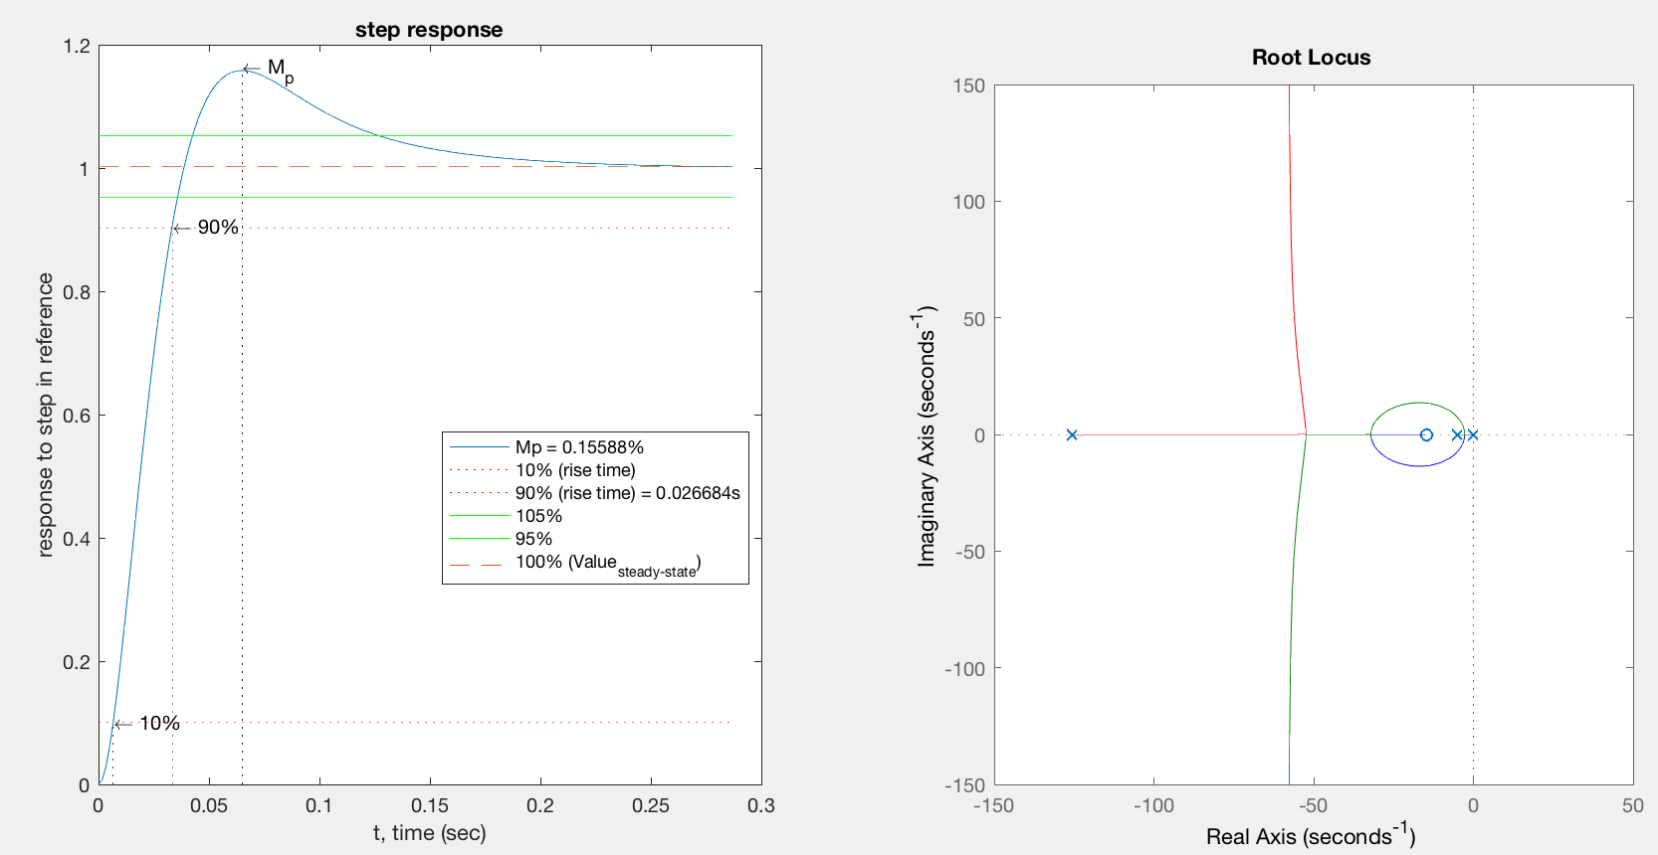

%% Prelab6 part e

% G

Kc = 2;

KT = Kc*K*Kpot*Kamp;

Den = conv([1,0],[tm,1]);

G = tf(KT,Den);

% Gc

num = conv(0.4,[1/2.3,1]);

Gc = tf(num,[1/92,1]);

figure(1)

margin(Gc)

% Realization of Close Loop System

HCL = tf(Gc*G/(1+Gc*G));

[y,t] = step(HCL);

% Mp

[M,MpIndex] = max(y);

yss = y(end);

Mp = M-yss;

if Mp<0

    Mp = 0;

else

    Mp =Mp/yss;

end

% tr

t_10index = find(  y > .1*yss, 1, 'first');

t_90index  = find(  y > .9*yss, 1, 'first');

tr = t(t_90index)-t(t_10index);

% Plots

figure(2)

subplot(121)

plot(t,y)

title('Step Response for KcG(s)Gc(s) for ','FontSize',14,'FontWeight','bold')

%plot the response and the bounds for 10%, 90%, 95% and 105%

ss = 1:1:size(t); % the final value

ss(:) = yss;

per105=1.05*ss;

per95=.95*ss;

per10=.10*ss;

per90=.90*ss;

plot(t,y,'-',t,per10,':r',t,per90,':r',t,per105,'-g',t,per95,'-g',t,ss,'--')

% document Mp

if(Mp > 0)

    text(t(MpIndex),y(MpIndex),'\leftarrow M_p',...

        'HorizontalAlignment','left')

    line([t(MpIndex);t(MpIndex)],[0,y(MpIndex)],...

        'Color','k','LineWidth',0.5,'LineStyle',':')

end

%document tr

text(t(t_10index),y(t_10index),'\leftarrow 10%',...

    'HorizontalAlignment','left')

line([t(t_10index);t(t_10index)],[0,y(t_10index)],...

    'Color','k','LineWidth',0.5,'LineStyle',':')

text(t(t_90index),y(t_90index),'\leftarrow 90%',...

    'HorizontalAlignment','left')

line([t(t_90index);t(t_90index)],[0,y(t_90index)],...

    'Color','k','LineWidth',0.5,'LineStyle',':')

%legend

legend(['Mp = ',num2str(Mp), '%'],...

       '10% (rise time)',...

       ['90% (rise time) = ',num2str(tr), 's'],...

       '105% ',...

       '95%',...

       '100% (Value_{steady-state})','Location','Best')

% Label the axes:

title('step response')

xlabel('t, time (sec)')

ylabel('response to step in reference')

% Root Locus

% Realization of G

Kc = 1; % Kc = 1 so we plot RL with Kc from 0 to inf

KT = Kc*K*Kpot*Kamp;

Den = conv([1,0],[tm,1]);

G = tf(KT,Den);

% Realization of Gc

Gc = tf([T,1],[T*alpha,1]);

% RL

subplot(122)

rlocus(Gc*G);

